**HON. PROF. rAKESH kUMAR mUDGAL**

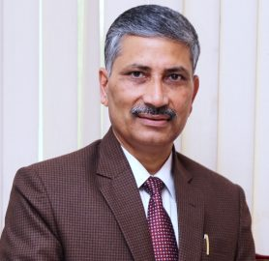

It gives me a great pleasure to share this message for the Department of Medicine, D.Y.Patil Education Society(Institution deemed to be university), Kolhapur who has its own website <http://www.dypmcmedicine.in>  keeping in view upgrading department. The Department of Medicine was established on 1990.

This is progressive step taken by this Department. This website will provide Departmental progress involving status of research.

I take this opportunity to appreciate the efforts of the faculty of the Department of Medicine and in particular Head of Department Dr. R. J. Khyalappa for launching such a website. I wish a grand success to this Department.

Hon. Prof. Rakesh Kumar Mudgal  
*Vice-Chancellor,*  
*D. Y. Patil Education Society, Kolhapur  India*

[.](https://skynetsabya.wordpress.com/2014/12/30/hon-dr-prakash-b-behere/)